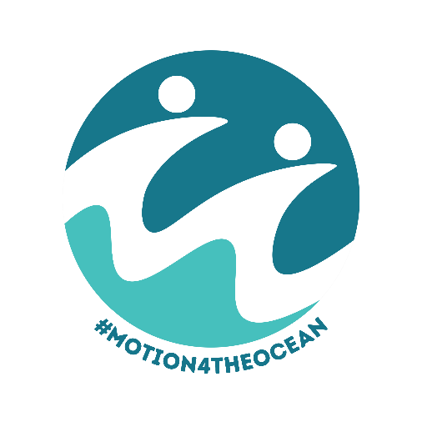
Motion for the Ocean (Coastal Council, England)

The Local Government Ocean Recovery Declaration
A model motion to help local authorities play their part in
realising a clean, healthy and productive ocean and all of
the direct economic, health and wellbeing benefits it will bring
What is the Motion for the Ocean?
Local authorities are working hard to bring about a brighter future for the communities we serve. We work to boost local economies, improve community health and wellbeing, and to protect and enhance local biodiversity. We know that the health, wellbeing and prosperity of coastal, estuarine and maritime communities is dependent on a clean, healthy and productive marine environment – yet too often we consider these issues separately, rather than thinking about it in a joined-up way.
Developed by leading ocean experts, Dr Pamela Buchan, Emily Cunningham MBE and Nicola Bridge, the #Motion4TheOcean has been created to enable local authorities to tackle these potentially competing ambitions of economic development, community health and wellbeing, and a healthy marine environment in a more holistic way. The motion aims to help councils and the communities we serve to “think ocean” and ensure the development of the blue economy delivers the recovery of our ocean and reducing socio-economic inequality in our coastal, estuarine and maritime communities.
The motion aims to help councils embed this new way of thinking at the highest levels of local decision-making, so it is not the responsibility of one team, but of the whole council. Councils of all tiers in England and Wales, along with the Local Government Association, have declared an urgent need for ocean recovery using a locally adapted Motion for the Ocean as can be seen on the dedicated webpage: Motion for the Ocean (see Appendix I). We look forward to seeing which council will be next.
Why is it important for councils to pass a Motion for the Ocean?
We recognise that our ocean and climate are in a state of emergency and that the communities we serve are on the frontline. An ocean in crisis is not only bad news for our climate, but also for our fishing, tourism, marine industries, and for the health, wellbeing, and stable prosperity of our coastal, estuarine and maritime communities. There are many opportunities for economic development in the marine environment, but these must be harnessed in a regenerative, rather than damaging, way.
Delivering the pledges set out in the Motion for the Ocean would yield new jobs and opportunities, more resilient coastal economies, and happier, heathier people; as well as a cleaner, healthier and more productive natural environment. A healthy ocean is an essential ally in our fight against climate change and blue carbon could play an integral role in helping us meet our net zero targets.
We have developed a Model Motion for the Ocean for inland councils which should be considered as a template to be adapted to local circumstances. We encourage local councils to adapt the pledges and wording, with the caveat that the ambition must not be reduced. We are happy to support in this process.

For any support, please contact: Pamela¹ | Emily² | Nicola³ | Beccy⁴ | Grace⁵

Model ‘Motion for the Ocean’ for Coastal Local Authorities

This Council declares an urgent need for Ocean Recovery.
We recognise that we need ocean recovery to meet our net zero carbon targets, and we need net zero carbon to recover our ocean.
This Council pledges to:
- Report to Full Council within [12] months on the actions and projects that will begin an ocean recovery in [COUNCIL AREA].

- Embed ocean recovery in all strategic decisions, plans, budgets, procurement and approaches to decisions by the Council (particularly in planning, regeneration, skills and economic policy), aligning with climate change mitigation and adaptation requirements, and considering ocean-based solutions in our journey towards a carbon neutral and climate resilient future.

- Ensure that local planning supports ocean recovery, working closely with the Marine Management Organisation to embed strong links between the Local Plan and its embedded links to the [area] Marine Plan to support ocean recovery.

- Ensure that our nature, biodiversity and climate strategies, such as the Local Nature Recovery Strategy, recognise how land and rivers connect to and impact the ocean and strive to support ocean recovery through a source-to-sea approach.

- Work with partners locally and nationally to deliver improved water quality and increased sustainability in marine industries, and to support the development of a sustainable and equitable blue economy that delivers ocean recovery and local prosperity; including the local fishing industry and the vital work of [local] Inshore Fisheries Conservation Agency.

- Grow ocean literacy and marine citizenship in [COUNCIL AREA], including:
  - Ensuring all pupils are given the opportunity to experience the ocean first-hand before leaving primary school - striving to include home-schooled children
  - Promoting sustainable and equitable access to the ocean through physical and digital experiences for all residents.
  - Through these actions, embed understanding of the “source-to-sea” approach and how all people, wherever they live, impact and are impacted by ocean health.

- Use the Council website and other communication channels to update on ocean recovery progress, and signpost to ocean literacy development opportunities and marine citizenship pledges.

- Write to the Government asking them to put the ocean into net recovery by 2030 by:
- Ensuring Inshore Fisheries and Conservation Authorities have the resources they need to effectively research and monitor our growing number of marine protected areas, and to set and enforce appropriate fishing levels that support local economies and deliver environmental sustainability.

- Working with coastal, estuarine and maritime communities to co-develop marine policy to ensure it delivers equitable and sustainable outcomes in local placemaking.

- Appointing a dedicated Minister for the Coast who can provide the strategic oversight needed to integrate cross-departmental working to support holistic change for communities and nature.

- Embedding ocean and civic literacy into the national curriculum and its local delivery.
- Stopping plastic pollution at source by strengthening the regulations around single-use plastics and set standards for microfibre-catching filters to ensure that all new domestic and commercial washing machines are fitted with a filter that captures a high percentage of microfibres produced in the wash cycle and support the solutions needed to address the threat posed by historic coastal landfill sites.

- Improving the water quality of our rivers, estuarine and coastal waters leading to the ocean to benefit nature and the health and wellbeing of all UK residents, including by stopping the regular pollution of our rivers and seas.

- And by listening to marine and social scientific advice to update the Marine Policy Statement and produce a national Ocean Recovery Strategy which will:

- Enable the recovery of marine ecosystems rather than managing degraded or altered habitats in their reduced state.
- Consider prosperity, marine conservation, energy, marine industries, flood and coastal erosion risk management, climate adaptation and fisheries policy holistically rather than as competing interests.

- Develop a smarter approach to managing the health of the entire ocean that moves beyond Marine Protected Areas and enables links to be made across sectors towards sustainability.

- Establish improved processes for understanding the benefits of ocean recovery, leaving no doubt the links between this and human lives, livelihoods, and wellbeing.

Glossary
A Blue Economy is one which uses ocean resources sustainably or even regeneratively whilst improving community wellbeing and social equity. It is not simply marine or maritime economic activity or “blue growth”.

Ocean literacy is where a person understands the ocean's influence on them and their influence on the ocean. For example, an understanding that the ocean stores carbon and an understanding that what they put down the drain can impact on ocean health. It can also include learning how to be an active marine citizen.

Marine citizenship is exercising the right to participate in the transformation of the human-ocean relationship for sustainability. This means taking individual and collective responsibility to consider one’s own and society’s impacts on the ocean; and exercising rights as a marine citizen, e.g. writing to a local Councillor to ask them to take action for ocean recovery; or promoting or making local, national or international policy changes.

Example context
The health of our ocean is inextricably linked with our climate and with human health, wellbeing and prosperity. A healthy ocean is fundamental in regulating the global climate system and is an essential ally in our fight against climate change. The ocean absorbs more than 90% of the excess heat in the climate system as well as absorbing around 20% of annual carbon dioxide (CO₂) emissions generated by human activity.
However, decades of irresponsible marine exploitation and pollution have led to significant levels of degradation, and this together with the detrimental impacts of our changing climate on marine ecosystems has led to national and global recognition that the world ocean is in crisis. An unhealthy ocean does not absorb or store carbon as effectively as a healthy one, further worsening the impacts of the climate crisis.
The UK government’s recent Marine Strategy assessment confirms that our marine environment is not healthy. An ocean in crisis is not only bad news for our climate, but also for our local fishing and tourism industries and for the health, wellbeing and prosperity of our coastal communities.
In [COUNCIL AREA], like the rest of planet, we are witnessing the ocean crisis first-hand. Fish stocks continue to collapse from permitted and illegal overfishing and poor water quality is impacting seafood and safe bathing. Our beaches are covered in litter with each tide, much of it plastic, though this is just the tip of the iceberg of the amount of litter in our oceans. Marine microplastics have been found in all marine environments and in the bodies of many species, including humans and the species of fish we regularly eat.
Our residents are on the frontline of climate change and are being disproportionately impacted relative to inland communities. The impact of the climate crisis on the ocean is profound, from rising water temperatures and changes in ocean chemistry, to sea level rise and increased storminess, including in our local waters. This is changing what seafood is caught locally, accelerating the erosion of our coastline - increasing the risk to infrastructure and properties, and increasing the risk of flooding and storm damage.
Urgent action is needed to halt these devastating changes and recover the health of our ocean to enable it to deliver the full range of benefits, including climate regulation, carbon storage in estuarine, coastal and marine habitats, coastal protection, a thriving local economy, clean safe recreation and happy, healthy coastal, estuarine and maritime communities. We must play our part in recovering the health of the ocean.
In [COUNCIL AREA], the ocean is at the heart of our heritage and economy. From the maritime and marine expertise around the [Name of] Port, to the millions of visitors who come to the [COUNCIL AREA] to experience the sight, sound and feel of the ocean. The ocean can play a vital role in our economic recovery and we must strive to develop a sustainable and equitable blue economy that delivers both ocean recovery and local prosperity. We must ensure that ocean recovery is embedded in our relevant strategic decision-making, policymaking and budget-setting; as well as being considered in future strategies and plans, including those seeking to improve the health and wellbeing of our residents.
At present, not everyone has the opportunity or means to access and enjoy the ocean. Even within [COUNCIL AREA], there are people of all ages who have never experienced the joy of our ocean. First-hand experience of the ocean is essential if people are to be motivated to play their part in protecting it, whether that is through disposing of their litter responsibly, recycling what they can or volunteering in ocean conservation with local organisations. Helping individuals develop their ocean literacy (understanding of the relationship between people and the ocean) is an essential part of this motion, as is individual and collective marine citizenship (promoting and demanding an ocean recovery through local, national and international policy changes).
Local authorities cannot solve the ocean crisis alone, but we can – and must – play our part.

Appendix I
Councils that have passed a Motion for the Ocean as at March 2025 with links to their Motion wording (where available).

- Plymouth City Council, 22 November 2021
- Falmouth Town Council, 10 January 2022
- South Tyneside Council, 13 January 2022
- North Norfolk District Council, 9 February 2022
- North Devon Council, 23 February 2022
- Monmouthshire County Council, 3 March 2022
- Seaton with Slingley Parish Council, 16 March 2022
- Seaham Town Council, 22 March 2022
- Torridge District Council, 11 April 2022
- Portsmouth City Council, 17 May 2022
- Devon County Council, 27 May 2022
- Blandford Forum Town Council, 25 July 2022
- Teignbridge District Council, 26 July 2022
- Blackpool Council, 20 November 2022
- Isle of Wight Council, 19 July 2023
- Canterbury City Council, 20 July 2023
- North Somerset Council, 19 September 2023
- Havant Borough Council, 20 September 2023
- Norwich City Council, 26 September 2023
- Newark & Sherwood District Council, 17 October 2023
- Lewes District Council, 20 November 2023
- Cornwall Council, 28 November 2023
- Nottingham City Council, 15 January 2024
- Colwick Parish Council, 16 January 2024
- Worthing Borough Council, 6 February 2024
- Walmer Town Council, 7 February 2024
- Stafford Borough Council, 27 February 2024
- Brandon and Byshottles Parish Council, 15 March 2024
- Forest of Dean District Council, 30 May 2024
- Swanage Town Council, 22 July 2024
- Gosport Borough Council, 16 October 2024
- East Lindsey District Council, 18 November 2024
- Boston Borough Council, 18 November 2024
- South Holland District Council, 18 November 2024

In addition to local Councils,, the Local Government Association declared a Motion for the Ocean on 29 September 2022.
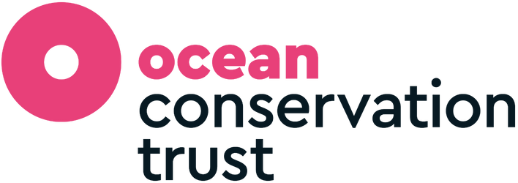
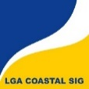

The Motion for the Ocean is supported in kind by the University of Exeter, LGA Coastal SIG, and the Ocean Conservation Trust.

